|  |
| --- |
| Cancer Care Ontario |
| Specialized Services Oversight (SSO) Data Dictionary |
| **Sarcoma Chemotherapy** |
| **11/8/2016** |

Table of Contents

Version Control 2

Appendix-6: Sarcoma Chemotherapy: Data Elements 2

Appendix-3: Facility Numbers 5

Appendix-11: Valid 2-digits Postal Codes 5

Appendix-14: Valid Drug Names 7

Appendix-22: Pharmaceutical dose unit 7

Appendix-23: Regimen List 9

# Version Control

|  |  |  |  |
| --- | --- | --- | --- |
| Date | Description | TFS# | Owner |
| October 27, 2015 | * Added Thunder Bay; removed Lakeridge; * Removed duplicate Cisplatin; added Vinorelbine to match template; * Removed duplicate CISPDOX-MTRX(HD) from regimen. * Updated Health_Card_Number validation to reference no 0's, no 1's * Updated Health_Card_Number validation to reference numbers less than 10 digits | -  -  -  234973  235429 | Michele Cross |
| November 8, 2016 | Added IFOS(HD) to the Regimen drop-down list (App. 23 in this document, and also on the template and on the back-end validation) | 698189  (700676) | Alex Platkin |
| August 30, 2017 | Kingston General Hospital facility number updated from 693 to 978 and name updated from Kingston General Hospital to Kingston Health Sciences Centre (KHSC) as a result of amalgamation of Hotel Dieu Hospital and Kingston General Hospital. Update was made both for facility / referring facility lookup fields where applicable. | 741614 | Raj Sreenivasan |

# Appendix-6: Sarcoma Chemotherapy: Data Elements

| **#** | **Entity** | **Data Element** | **COLUMN_NAME** | **Definition (Description)** | **Format** | **Valid values (Notes)** | **Apples to** | **Purpose and Use** | **Mandatory** | **Business key (Uniqueness)** |
| --- | --- | --- | --- | --- | --- | --- | --- | --- | --- | --- |
| 1 | Sarcoma -  Chemotherapy | Health Card Number | Health_Card_Number | Patient's Ontario Health Card Number. | CHAR(10) | Valid values: valid HCN  Not valid: 0-unknown, 1-out of country (OOC), or number less than 10 digits | All | To link data with other CCO data holding areas. | Yes |  |
| 2 | Sarcoma -  Chemotherapy | Patient chart Number | Patient_Chart_Number | Facilites infernal chart number | CHAR (12) | Must be alpha-numeric (i.e. no punctuation, must have numbers and characters). | All | For reimbursement: to uniquely identify procedure for a patient;  For investigations: chart number will be provided in log file for the records with errors. This will allow facilities to link data in log file with their data sets. | Yes | Yes |
| 3 | Sarcoma -  Chemotherapy | Date of Birth | Date_Of_Birth | Patient birth date | CHAR (8) YYYYMMDD | Valid | All | To link data with other CCO data holding areas. | Yes |  |
| 4 | Sarcoma -  Chemotherapy | Postal Code | Postal_Code | Patient’s residential postal code. | CHAR(10) | 1. Must match any of these format masks: ANANAN, NNNNN, NNNNN-NNNN, AA  2. If matches mask ANANAN, then can’t begin with D,F,I,O,Q,U, or W  3. If matches mask of AA, then should match any entry in **Appendix-11** (Province and State Codes). | All | For geographical distribution reporting. and program planning. | Yes |  |
| 5 | Sarcoma -  Chemotherapy | Facility Number | facility_number | Submitting facility number | CHAR(3) | Valid facility number listed in **Appendix-3** | All | For funding and planning | Yes | Yes |
| 6 | Sarcoma -  Chemotherapy | Patient type | patient_type | Identifies whether patient is inpatient/outpatient at the reporting hospital | CHAR(15) | Valid Values: Inpatient/Outpatient | All |  | Yes |  |
| 7 | Sarcoma -  Chemotherapy | Drug name | drug_name | Name of the drug used for systemic treatment | CHAR(25) | Valid drug names listed in the **Appendix-14** | All | For funding and planning | Yes | Yes |
| 8 | Sarcoma -  Chemotherapy | Drug name other | drug_name_other | Name of the other drug used for systemic treatment | CHAR(50) | Free text. alphanumeric | All | For funding and planning | No |  |
| 9 | Sarcoma -  Chemotherapy | Drug dose | drug_dose | Dose amount | INTEGER (38) | Numeric amount of drug | All | For funding and planning | Yes |  |
| 10 | Sarcoma -  Chemotherapy | Dose unit | dose_unit | Dose unit for particular drug such as mg | CHAR(10) | Valid values for the dose unit listed in the **Appendix-22** | All | For funding and planning | Yes |  |
| 11 | Sarcoma -  Chemotherapy | Treatment date | Treatment_date | Date when patient was treated | CHAR(8) YYYYMMDD | Must be with in submitting quarter and year | All | For funding and planning | Yes | Yes |
| 12 | Sarcoma -  Chemotherapy | Regimen | Regimen | A set of anti-cancer and supportive medications given during an active course of systemic chemotherapy | CHAR (22) | Valid regimen codes listed in CCO provincial regiment list in **Appendix**-**23** | All | For funding and planning | Yes |  |
| 13 | Sarcoma -  Chemotherapy | MCC date | MCC_ date | MCC date | CHAR(8)  YYYYMMDD | Valid date. | All |  | No |  |
| 14 | Sarcoma -  Chemotherapy | Cycle Number | Cycle_Number | The cycle number for the current cycle of chemotherapy that the patient is receiving at treatment visit. | CHAR (2) | Must be a numeric value, value must be greater than 0 | All | For reimbursement, for program planning. | Yes | Yes |

# Appendix-3: Facility Numbers

|  |  |  |  |
| --- | --- | --- | --- |
| **#** | **Program Title** | **Submitting Hospital** | **Facility Number** |
| 2 | a) Sarcoma (Chemotherapy)  b) Sarcoma (Pathology)  c) Sarcoma (Prosthesis) | Royal Victoria Regional Health Center | 606 |
| Kingston Health Sciences Centre (KHSC) | 978 |
| Grand River Health Corporation | 930 |
| Windsor Regional Center | 933 |
| Thunder Bay Regional Health Sciences Centre | 935 |
| London Health Sciences | 936 |
| Hamilton Health Sciences Corporation | 942 |
| University Health Network | 947 |
| Sunnybrook Health Sciences Centre | 953 |
| The Ottawa Hospital | 958 |
| Health Sciences North | 959 |
| Sinai Health System | 976 |

# Appendix-11: Valid 2-digits Postal Codes

(Source: Cancer Care Ontario's Data Book - 2012-2013, Appendix B - Province and State codes, at link https://www.cancercare.on.ca/ext/databook/db1213/databook.htm).

The table below provides list of valid 2 digit postal codes for province and State codes.

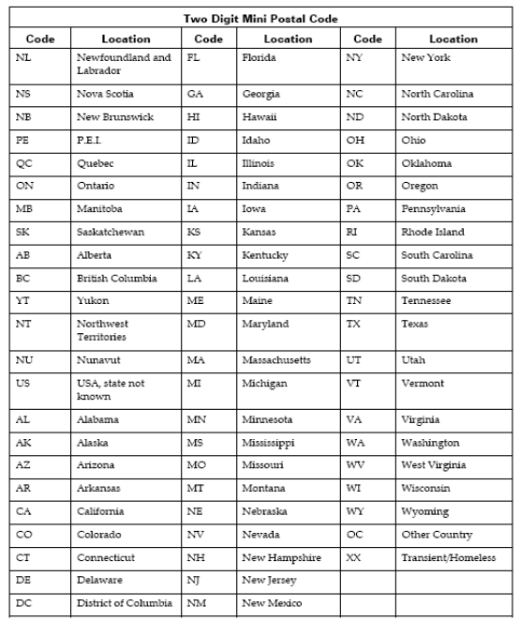

# Appendix-14: Valid Drug Names

|  |  |
| --- | --- |
|  | **Valid Drug Names** |
|  | Cisplatin |
|  | Cyclophosphamide |
|  | Docetaxel |
|  | Doxorubicin |
|  | Epirubicin |
|  | Etoposide |
|  | Gemcitabine |
|  | High Dose Ifosfamide |
|  | High Dose Methotrexate |
|  | Ifosfamide |
|  | Mesna |
|  | Methotrexate |
|  | Other |
|  | Topotecan |
|  | Vinblastine |
|  | Vincristine |
|  | Vinorelbine |

# Appendix-22: Pharmaceutical dose unit

This table provides info for Radio pharmaceutical dose unit

| **Unit Code** | **Description** |
| --- | --- |
| cap | capsule |
| MBq | megabecquerels |
| mcg | microgram |
| mEq | milliequivalent |
| MU | million units |
| tab | tablet |
| unit | unit |
| mg | milligram |
| mL | milliliter |
| drop | drop |
| pfu | plaque forming unit |
| cm | centimeter |
| g | gram |
| loz | lozenge |
| mmol | millimoles |
| part | particle |
| ptch | patch |
| pkt | packet |
| pop | popsicle |
| puff | puff |
| spry | spray |
| supp | suppository |

# Appendix-23: Regimen List

A set of anti-cancer and supportive medications given during an active course of systemic chemotherapy that is named and defined in CCO's Provincial Formulary Regimen List.

| **Regimen Name** | **Description** |
| --- | --- |
| CISPDOX-MTRX(HD) | OSTEOGENIC SARCOMA (CISPLATIN,DOXORUBICIN,METHOTREXATE) |
| CYCLTOPO | SARCOMA OR NEUROBLASTOMA - TOPOTECAN, CYCLOPHOSPHAMIDE |
| DOCEGEMC | GI,PANCREAS OR LUNG,NSCLC OR GU,BLADDER OR GYNECOLOGICAL OR BREAST OR HEMATOLOGY OR HEAD AND NECK OR SARCOMA - GEMCITABINE, DOCETAXEL |
| DOXOIFOS | SARCOMA OR GYNECOLOGICAL, IFOSFAMIDE-DOXORUBICIN (+ MESNA) |
| EPIRIFOS | SOFT TISSUE SARCOMA (IFOSFAMIDE,EPIRUBICIN,MESNA) |
| ETOPIFOS | SARCOMA, IFOSFAMIDE-ETOPOSIDE (MAY USE MESNA) |
| GEMC | GI,PANCREAS OR LUNG,NSCLC OR GU,BLADDER OR GYNECOLOGICAL OR BREAST OR HEMATOLOGY OR HEAD AND NECK OR SARCOMA - GEMCITABINE |
| IFOS | SARCOMA OR GYNECOLOGICAL OR GENITOURINARY, IFOSFAMIDE (+ MESNA) |
| IFOS(HD) | SARCOMA - IFOSFAMIDE (HIGH DOSE) (+ MESNA) |
| MTRX(HD) | GYNECOLOGICAL - GESTATIONAL TROPHOBLASTIC NEOPLASIA OR HEMATOLOGY OR SARCOMA OR UNKNOWN OR CNS, METHOTREXATE (> OR = 100MG/M2)) |
| MTRXVINO | SARCOMA -SOFT TISSUES, VINORELBINE - METHOTREXATE |
| MTRXVNBL | SARCOMA -SOFT TISSUES, VINBLASTINE - METHOTREXATE |
| VAC | GYNECOLOGIC SARCOMA (vinCRIStine; DOXOrubicin; Cyclophosphamide) |